We got to know about the ACM hackathon by the ACM Stanley coordinators and got ourselves enrolled. The **Stanley & BITS Pilani ACM-W Hackathon 2024** was a prestigious event that brought together tech enthusiasts to showcase their skills in problem-solving and innovation. Jointly organized by **Stanley College of Engineering & Technology for Women** and **BITS Pilani, Hyderabad**, the hackathon took place on **November 8, 2024**, offering **₹15,000 cash prize** to the winners.

|  |  |
| --- | --- |
| WhatsApp Image 2025-04-04 at 19.04.37.jpeg | WhatsApp Image 2025-04-04 at 19.11.52.jpeg |

This hackathon taught us a lot, not only about technical knowledge, but also about collaboration, team work and adaptability as well. This was our first hackathon. We were new to everything and we were competing with many people who had won and participated in many hackathons. We were a team of 3 members with the team name as **“FUTURE INSIGHTS”**. As time was less we split the work among ourselves so that at the end of the day we could build the webpage of the problem statement. Our problem statement was to create a solution that identifies and suggests potential career paths based on individual skills or interests, providing users with direction in their career exploration. So we designed a webpage for under graduates to assist them to either take-up a Job or go for higher studies.

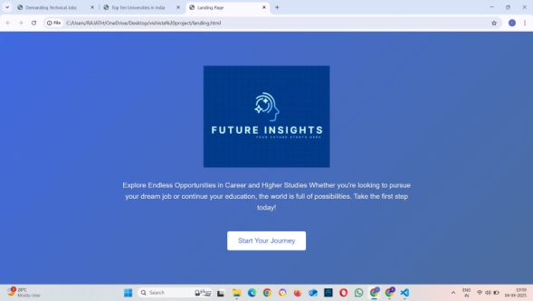The web page portal begins with a logo and quotation stating as **“Explore Endless Opportunities in Career and Higher Studies whether you're looking to pursue your dream job or continue your education, the world is full of possibilities. Take the first step today!”** and this page leads to a login/signup page and then to an index when logged in to opt for higher studies or placements. If higher studies is selected, a page opens for student to witness the top countries and universities available in those countries. By selecting a particular university will take user to the original home page of that university. If placement is selected, students get to choose technical or non technical jobs. Under this, we get to witness the top priority jobs offered and skills required to get a job and by choosing a skill, you will be guided to the relevant YouTube page where one can get all the playlists or videos which would help in leaning those skills. We used HTML, CSS and Java script to build this web page. We designed the web page with a simple and intuitive UI so that options are easily navigated by a user. Due to stipulated time race, we could not add many features that we initially thought of during design discussions but were able to fulfill the basic requirement of web page creation to serve the required purpose.

It was totally a helpful thing for making us to race against the time and building the webpage. We divided the work among ourselves. One of us build the higher studies based pages and designing them. Another one worked to build the pages related to the placements while the third one had designed the landing page and clubbed the placement and higher studies pages. The main issue in our journey of the hackathon was to verify each and every university main pages so that they are genuine and all the playlist which were recommended for building the skills were also verified. During this phase we had even encountered few fake websites. So our moto was to give a 100% genuine information from our webpage. After the long day with fixing bugs, verifying the stuff, making changes to the code and interface design, we were finally able to build a running web page for the career guidelines. Around 6pm we presented our work to the judges. At that time 1000 of thoughts were running in our mind as it was our first hackathon but finally we gained the confidence and explained the work to the judges and they were impressed the idea of leading users to the playlists and the original web pages of the universities. We were informed that the results would be released within two days. So we were hoping for the best. At last the waiting moment came and we were informed that we stood second in the hackathon and our happiness had no limits as we hit a jackpot. This winning moment boosted the confidence in us that we can win if we give our 100% effort. We received Rs.5000 as the cash price. This is one of the best moment in my engineering life.

|  |  |
| --- | --- |
| WhatsApp Image 2025-04-04 at 22.52.19.jpeg | WhatsApp Image 2025-04-04 at 22.55.36.jpeg |